Name: Niko Andrei M. Pepito Date:09-15-25
Schedule:1:30-3:00pm Subject:IMDBSYS31 LAB

Laboratory Exercise No. 3
A.

- Create Database (name)

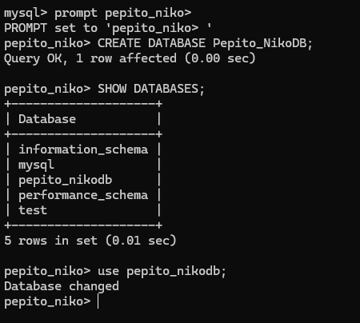

- Create Tables

- Create Table (Table name)

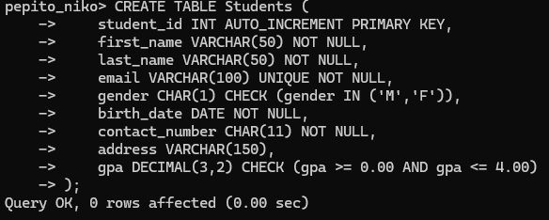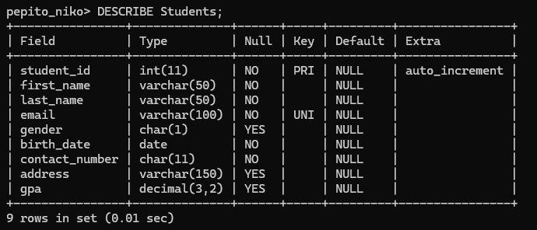

- Create Table (Table name)

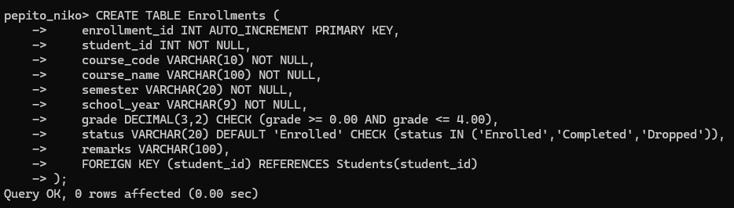
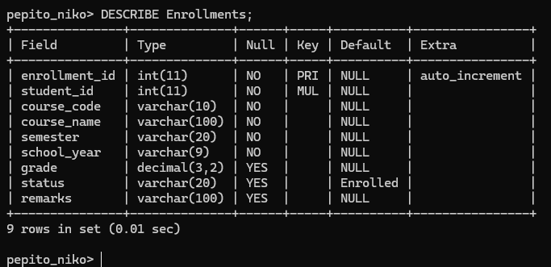

B.

- Create Database (name)

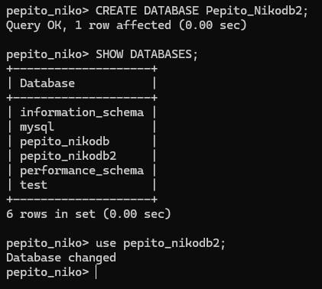

- Create Tables

- Create Table (Table name)

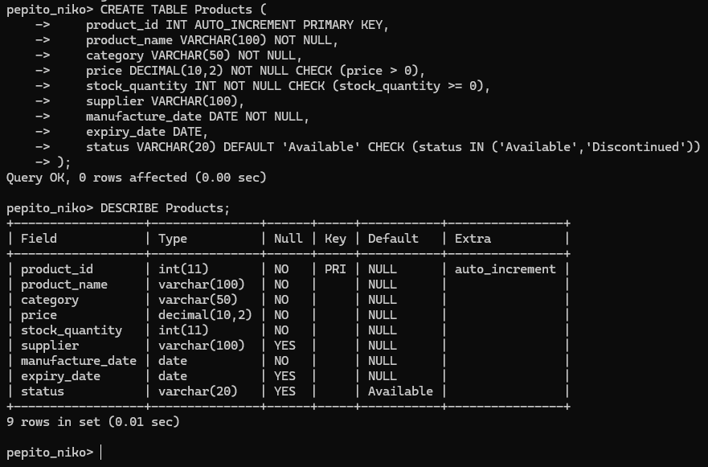

- Create Table (Table name)

